Master of Science in Business Administration

What You Gain

Value Proposition

The College of Business at the University of Illinois is recognized as a premier global institution for management and business leadership training. The strength of the Master of Science in Business Administration (MSBA) degree is based on the college’s history of world class programs and its ability to provide students with technical skills and opportunities for personal growth and lifelong learning. Its worldwide network of alumni and industry connections will benefit students throughout their careers.

The mission of the MSBA program is to provide a high quality business education to those who strive to become leaders in business, government, and education. The
MSBA program is committed to academic excellence, maintaining a collaborative learning environment, providing high quality student service, and developing lifelong learning skills.

- Learn to combine your knowledge and problem-solving skills in disciplines such as economics, finance, marketing, operations, management, and accounting
- Enhance the development of critical managerial skills in the areas of leadership, teamwork, ethics, and communication

- Obtain a firm understanding of international management strategy and global business operations

- Gain a deep appreciation for using business tools for decision making and formulating global strategy

- Enrich your capacity to learn new concepts, think critically, and prepare for the challenges of tomorrow in a global environment
ADMISSIONS

Admission decisions are made by the admissions committee and are based on:

- previous academic accomplishments

- demonstrated potential for graduate and professional success

- references and test scores

- work experience

MSBA Admissions strives for balanced geographic and industry representation in the makeup of each class. Admissions will notify applicants in writing as soon as a decision is made.

Apply

Our application for the 2014 MSBA class (start date of August 2013) is open. We welcome you to apply at this time, if you feel you are a qualified candidate and possess:

- A bachelor's degree or the equivalent with a 'B' or better grade point average (3.0 on 4.0 scale) from an accredited institution in the United States or a recognized institution of higher learning outside the United States.

- A minimum TOEFL (Test of English as a Foreign Language) score of 102 iBT, 254 computer-based or IELTS of 6.5 or higher. (Required to be admitted full status, if you are an international applicant. Lower scores may be considered based on the complete admission application.)

Recent undergraduates or individuals with two years or less of full time work experience are encouraged to apply. The GMAT or GRE is not required, but the scores will be taken into account if applicants wish to submit their scores with their application.

Please read and follow all instructions carefully. The MS in Business Administration
Admissions Committee will only consider complete, correctly prepared applications accompanied with the application fee and appropriate documentation.

Apply Now
Upon receipt of a completed application, the Admissions Committee will review your documentation. No partial evaluation of incomplete applications will be made. Applications are reviewed on a rolling basis with priority admission to applications received first beginning February 1, 2013.

The decision of the MSBA Admissions Committee will be sent by email to the email address listed on the application. If the applicant is recommended for admission, the University of Illinois' Graduate College will evaluate official credentials and financials and send the Notice of Official Admission, produced by the Graduate College Office of Admissions and Records, to those approved for admission. For international applicants, this will include financial documentation and visa paperwork, either the I-20 or DS-2019, as necessary to receive a visa to study in the United States.

Application Deadline

All completed applications are reviewed beginning in January and considered as long as space is available in the program. Candidates are advised to submit their complete application by March 30 with international applicants reminded to submit complete applications sooner to allow sufficient time to obtain visas for admittance to the United States.

Application Checklist

The application must be complete in order to be submitted and be eligible for review.
You will be able to save your application and return to it. A completed application includes the following documents to be entered and/or uploaded into the application:

- Résumé

- Essays (the application will provide details of questions)

- Unofficial Transcripts (if an offer of admission is made, the OfficialTranscript(s) is required to be submitted upon arrival to campus)
- Degree Certificate/Diploma (if an offer of admission is made, the Official Degree Certificate(s)/Diploma is required to be submitted upon arrival to campu.)

- Three (3) Letters of Recommendation (enter the name and email address of 3 recommenders. The application system will send emails to the Recommenders and request their electronic submission)
- Online Application fee payment (you must use a credit card to pay on-line)

International applicants also need to include:

- English Language Test Score (TOEFL (from ETS) or IELTS score). TOEFL scores must be sent to the U of I directly from ETS using Institution Code: 1836, Department Code: 00. For IELTS scores, you should upload a copy of your score card.

- Declaration & Certification of Finances form Print, complete and upload.
- Bank statements

- Financial affidavit or sponsorship letter (if applicable)

- Passport photo

Application Instructions

Upload All Application Materials into the Graduate Application.

For additional information and/or questions, contact:

Mandy Chapman.
MS in Business Administration
Department of Business Administration
College of Business, University of Illinois
1206 South Sixth Street, 350 Wohlers Hall
Champaign, IL 61820 USA

Tuition, Fees and Other Expenses

 | MSBA | Tuition | Fees | Total
 | Fall 2013 | $13,540 | $4,615 | $18,155
 | Spring 2014 | $13,540 | $4,615 | $18,155
 | Summer 2014 | $6,770 | * | *
*Not available at this time.

- Tuition and fees are assessed at the time a student enrolls in the University and are due September 28, February 28, and June 28, respectively. Details about each of the University fees and assessments can be found at the University's Admission tuition details.

- Room and board, books and supplies, and other expenses vary from student to student but are estimated annually at $17,566, $2,100, and $3,625, respectively. The Office of Student Financial Aid lists detailed descriptions for each of these categories.

- International students are assessed an additional $35 per semester to help support ISSS operations. International student will need to verify financial capability for tuition, fees, room & board, and living expenses prior to admission.

- Travel and workshop expenses are included in the fees. This excludes the optional study travel and abroad trips provided by the college.
- Students should allow for an additional contingency fund of $3,000 for initial expenses.

If a student does not finish the program in three semesters, additional tuition and fees will be charged for each additional semester the student attends to finish the program.
Tuition and fees assessed for any semester, term, or summer session are due and payable in full by the deadline indicated on the Student Accounts Receivable Statement.

University Student Financial Services & Cashier Operations (USFSCO) has some good advice about how to setup and maintain a student account.

International Students

International applicants must meet minimum requirements based on their country of origin. Check the minimum requirements for applicants from your country.

International students can join the University of Illinois at Urbana-Champaign on one of two visa types: F-1 "student" or J-1 "exchange visitor student." Upon admission, an international student is usually sent an I-20 to obtain F-1 status.

There are three exceptions:

- Students already in the United States on a J-1 student status will be sent a DS-2019 to continue in that status. Some students in J-1 status are not permitted to change status to F-1 within the United States.
- Students already under the sponsorship of an agency for J-1 status (e.g., AAI, LASPAU, AID, IIE) receive a DS-2019 from that agency.

- Students who request a DS-2019 to come to the United States in J-1 status because of the advantages of that option, may be sent a DS-2019. Please note that students who receive at least half of their funds from personal or family sources are not eligible to obtain J-1 status.

Students with questions about the effect of J-1 versus F-1 status in their particular circumstances should contact:

International Student and Scholar Services
610 East John Street Room 331 Champaign, Illinois 61820 -5782 USA Telephone: 217-333-1303
E-mail: oisa@illinois. edu, isss@illinois.edu http://isss.illinois.edu
Program Curriculum

The course requirements for the MSBA program consist of 40 credit hours drawn from a set of Business core courses, International management core and elective courses in
Business Administration.

MSBA CORE COURSE CURRICULUM
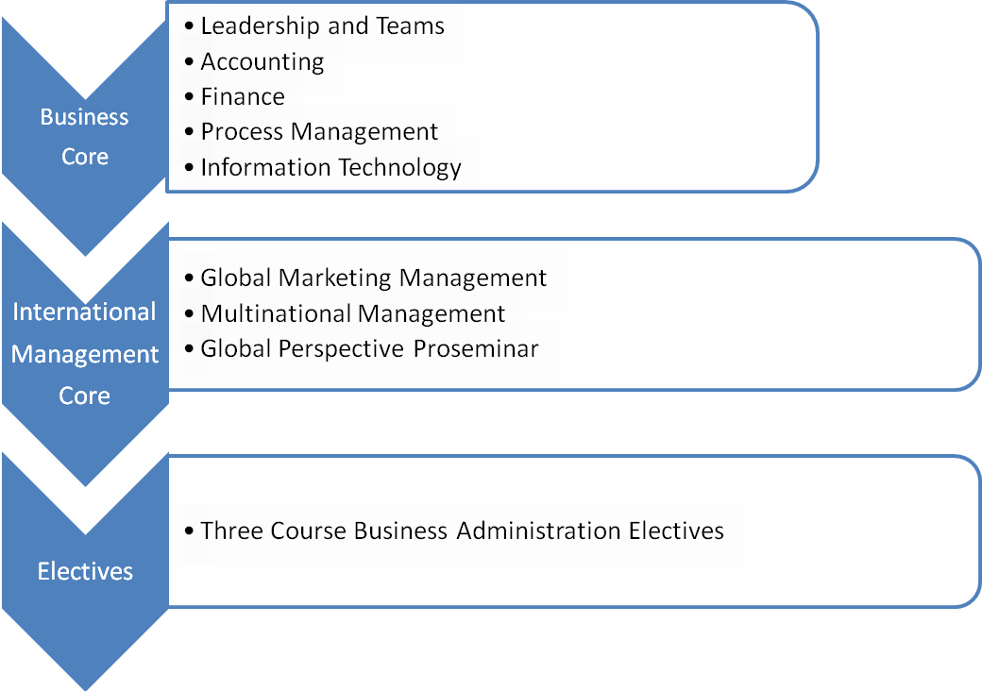

Our courses are progressively structured and delivered in both eight and sixteen week modules, which allows us to dive deep into a vast array of important topics over the one year time frame of the MSBA Program. There is even the chance for enterprising students to further refine the curriculum to suit their personal needs with additional courses from the University of Illinois' vast course catalog, a minor in accountancy, finance, corporate governance and international business, or information technology. A minor generally requires an additional semester of study.
MSBA HYPOTHETICAL THREE COURSE CONCENTRATION
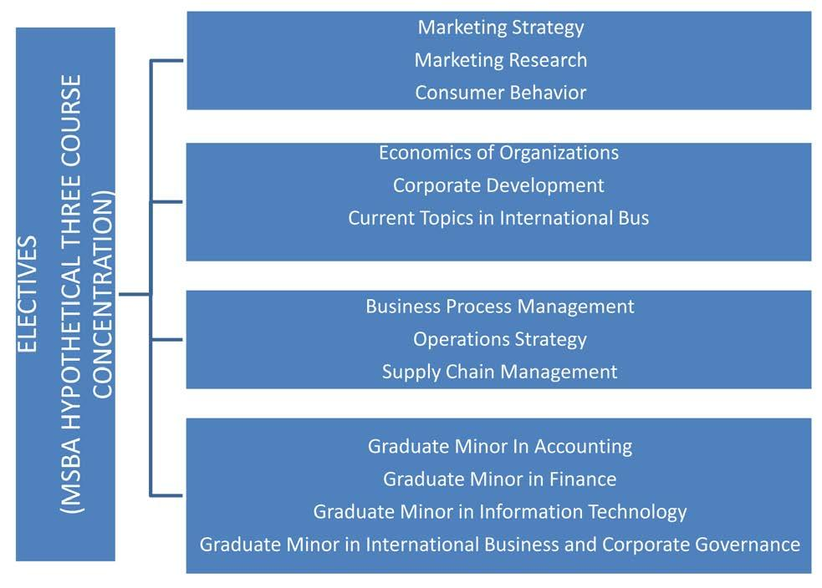

Students must select at least three College of Business courses from the list of approved courses to fulfill the elective course requirement. A student who elects not to pursue a minor or concentration will select their electives to form a coherent program of study from courses offered in BADM.

Course | # | Title
BADM | 521 | Marketing Strategy
BADM | 528 | Promotional Strategy
BADM | 529 | Marketing Research
BADM | 523 | Consumer Behavior
BADM | 583 | Current topics in IB
BADM | 582 | Multinational Management
BADM | 586 | International Comparative Mgmt
BADM | 553 | Ethical Dilemmas in Business
BADM | 590 | Global Strategy
BADM | 566 | Supply Chain Management
BADM | 590 | Business Process Management
BADM | 590 | Corporate Development
BADM | 590 | Economics of Organization
BADM | 590 | Operations Strategy
BADM | 590 | Entrepreneurship Small Bus.
BADM | 590 | E-business/Social Media
BADM | 557 | Decision Support/Knowledge
BADM | 556 | Electronic Commerce
BADM | 555 | Enterprise Data Management
BADM | 458 | IT Governance
BADM | 453 | Decision Support Systems
BADM | 590 | IT Network Organization
BADM | 590 | IT E-business Strategies

Detailed descriptions of each core course can be found at Courses

Courses

The coursework can be divided into three categories: core business courses to build a solid business foundation, international management courses specifically designed for our program and program electives. Core courses build a strong business base found in any graduate business program, (e.g., Organizational Behavior, Process Management, Marketing, Accounting, Finance) as well as courses in functional areas of global business administration (e.g., Global Marketing, Multinational Marketing

Courses are taught in eight weeks to semester long modules that build upon each other. In the final semester students further synthesize the knowledge learned throughout the program.

Accounting

This course covers financial, managerial, and cost accounting. This course lays an important foundation, since you will need to understand financial statements, cost systems, and cost behavior for this program and your career. The course studies information that is:

- Measured, reported to and used by individuals and entities external to organizations - generically known as financial accounting.

- Measured, reported and used within organizations - generically known as managerial accounting.

Students will have an opportunity to examine transactions, events, and practices that occur in the context of several functional areas - such as production, operations and marketing — and subsequently study how accounting systems interact with them.
Students will emerge from the course as more financially literate individuals who can understand the linkages between accounting and other business disciplines.

Global Perspective PROSEMINAR

This course enhances the work done in the classroom through an ongoing series of seminars and workshops, corporate visits both from business leaders and to various headquarters, and talks by corporate executives and entrepreneurs. Topics that will be covered include but are not limited to leadership and negotiation, business ethics, career planning, networking, and corporate governance.

Introduction to Finance

This course provides an introduction to financial management and decision making for graduate students who do not necessarily have previous training in the discipline of making decisions pertaining to investments in projects and financing their operations.

Topics covered include: an overview of financial environments, valuation of securities, risk- return relationships, capital budgeting, financial analysis and planning, cost of capital, and options.

Global Marketing Management

There are three main learning objectives for this course. First, the students learn the terminology, institutions, and programs of modern marketing. Second, we focus on the strategic analysis of marketing opportunities, and the communication of marketing decisions through the case analysis method. Third, students must apply this knowledge in an innovative and interactive marketing simulation for their final project.

Leadership and Teams

Many organizations and their managers today recognize that the critical sources of competitive advantage lie in not only ingenious product design, brilliant marketing strategy, or state-of-the-art production technology, but also in having an effective system for obtaining, mobilizing, and managing the organization's human assets. Essentially, the design and management of effective organizations is a major source of a competitive edge. A number of developments are making organizational design and its management increasingly salient for managers, such as the changing characteristics of the labor force, the rapid pace of technological innovation, greater international competition, and greater attention to diverse customers.

The main objective of the course is to introduce the basic concepts, theories, and techniques necessary for understanding, designing, and managing organizations that achieve value creation. Instead of focusing purely on the individual employees, their motivation, or leadership, this course emphasizes the tasks of organizational units, their internal processes, and the overall design for effective functioning of organizations that can execute business strategies within an ever-changing context.

The course is based around four fundamental questions about designing and managing organizations. First, how should firm strategies and business models be taken into account when designing organizations? Second, what are some of the basic issues and principles of designing the overall structure of the organization? Third, how should managers design performance measurement systems for managing their critical resources that can lead to successful implementation of their business strategies? And lastly, how can managers put all these elements together to make their organizations perform well and change in today's rapidly evolving business environment?

Multinational Management

Examines critical issues facing managers who work in multinational firms. Designed to develop students' skills for working in a global business environment. Topics include

foreign market entry strategies, global management of the functional areas of business, and management and control of multinational firms in the global marketplace.

Information Technology

Process Management involves ensuring that the underlying product or service is of the highest quality, that the appropriate design and technology is chosen for the production or service process, the planning and control of the flow of parts or customers is managed so that lead times are reduced to minimal levels, and the distribution of the finished goods or services is efficiently done. Process Management requires making decisions to handle issues that range from how to ensure that the customers get products on time, to determining how much capacity is needed to provide a high level of service, to evaluating which technology will best meet a given company's needs.

Process Management/Project Management

The course focuses on fundamental principles for designing a new process, improving an ongoing process, and managing a process to ensure customer satisfaction. This course is a foundational one for Supply Chain Management, which looks at linkages across organizations, whereas Project Management is a more specialized body of knowledge for a specific type of process aimed at answering the "How" questions.

